SCC 461 Coursework 0

36071280

10/10/2021

Q1. Write code for log(PCB) against age, reproducing the final plot containing both the equation line and the data points.

#Task 1 - Reproducing the plot for age vs. log(PCB)  
  
ages <- seq(from=0, to=13, by=0.1)  
a <- -2.3907  
b <- 2.300  
l <- a + b*ages^(1/3)  
trout.age <- c(1, 1, 1, 1, 2, 2, 2, 3, 3, 3, 4,4, 4, 5, 6, 6, 6, 7, 7, 7, 8, 8,  
 8, 9, 11, 12, 12, 12)  
trout.pcb <- c(0.6 , 1.6, 0.5, 1.2, 2.0, 1.3, 2.5,2.2, 2.4, 1.2, 3.5, 4.1, 5.1, 5.7,  
 3.4, 9.7, 8.6, 4.0, 5.5, 10.5, 17.5,13.4, 4.5, 30.4, 12.4, 13.4, 26.2, 7.4)  
plot(x=trout.age, y=log(trout.pcb), main="Log(PCB) vs Age", xlab = "Age ->", ylab = "Log(PCB) ->")  
lines(x=ages, y=l, type="l", col="blue")

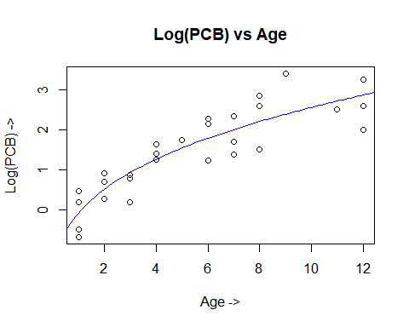

Q2. Rewrite the log(PCB) equation as a function which has arguments; a, b, and age, and returns the predicted log(PCB).

#Task 2 - Rewrite log(PCB) as a function  
  
calc_PCB = function(a, b, age) {  
 predicted_l <- a + b*age^(1/3)  
 return (predicted_l)  
}

Q3. By extending the range of age considered, produce a plot which shows the curve for the expected log(PCB) concentration for lake trout up to 20 years old.

#Task 3 - Extend ages to 20 years  
  
ages_20 <- seq(from=0, to=20, by=0.1)  
plot(x=ages_20, y=calc_PCB(a,b,ages_20), "l", col="green", main="Log(PCB) vs Age for 20 years",   
 xlab="Age ->", ylab="Log(PCB) ->")

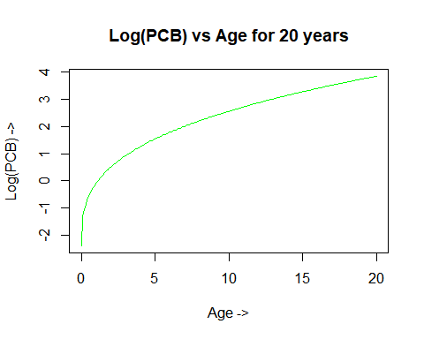

Q4. Now extract the maximum expected/predicted log(PCB) from the values used to draw the equation line

#Task 4 - Get Maximum  
print(paste0("Maximum value is :", max(calc_PCB(a,b,ages_20))))

## [1] "Maximum value is :3.85246051816828"

Q5. It can be shown that a non-linear model of the form l = a + b × age^c where a, b, and c are constants provides a slightly better fit to the data. The optimal choices are a = -4.865, b = 4.7016, and c = 0.1969.

#Task 5 - Non-linear model  
  
a2 = -4.865  
b2 = 4.7016  
c2 = 0.1969

1. Rewrite the log(PCB) equation as a function which has arguments; a, b, c and age, and returns the predicted log(PCB).

# Task 5.1 - Rewrite log equation function  
  
calc_PCB2 = function(a,b,c,age) {  
 predicted_l = a + b * (age^c)   
 return (predicted_l)  
}

1. Compare the Bates-Watts estimator and the new estimator for the expected log(PCB) concentration of a 10 year old lake trout.

# Task 5.2 - Compare  
  
fixed_age = 10  
value_BWEstimator = calc_PCB(a,b,fixed_age)  
value_newEstimator = calc_PCB2(a2,b2,c2,fixed_age)  
  
value_newEstimator == value_BWEstimator

## [1] FALSE

1. Create a new plot which has both the old line and new line, allowing a comparison of the differences.

# Task 5.3 - Plot both equations  
  
plot(x=ages, y=l, type="l", col="red", ylab = "Log(PCB) ->", xlab = "Ages ->",   
 main="Comparing Bates-Watts estimator and the new estimator")  
lines(ages, calc_PCB2(a2,b2,c2,ages), type="l", col="orange")

